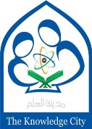 **The Knowledge City School**

**Mid-Term Examination 2019 – 20**

|  |  |
| --- | --- |
| Name: | Total Marks: 50 |
| Class: IV | Marks obtain: |
| Date: | Time: 2 hours |

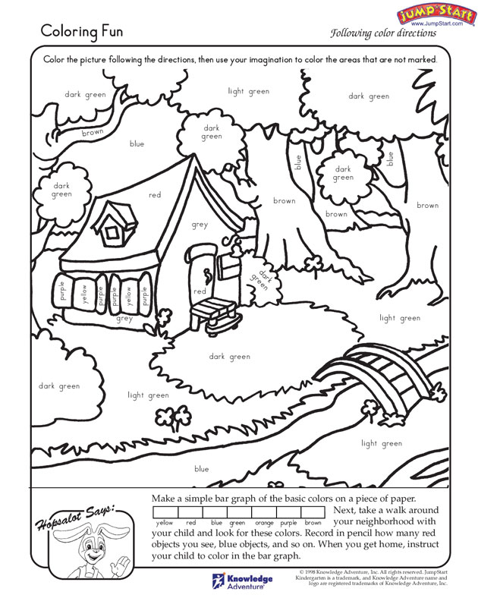**Q1: Colour the given picture by using one type of stock. 10**

Q2: Complete the picture? (10)

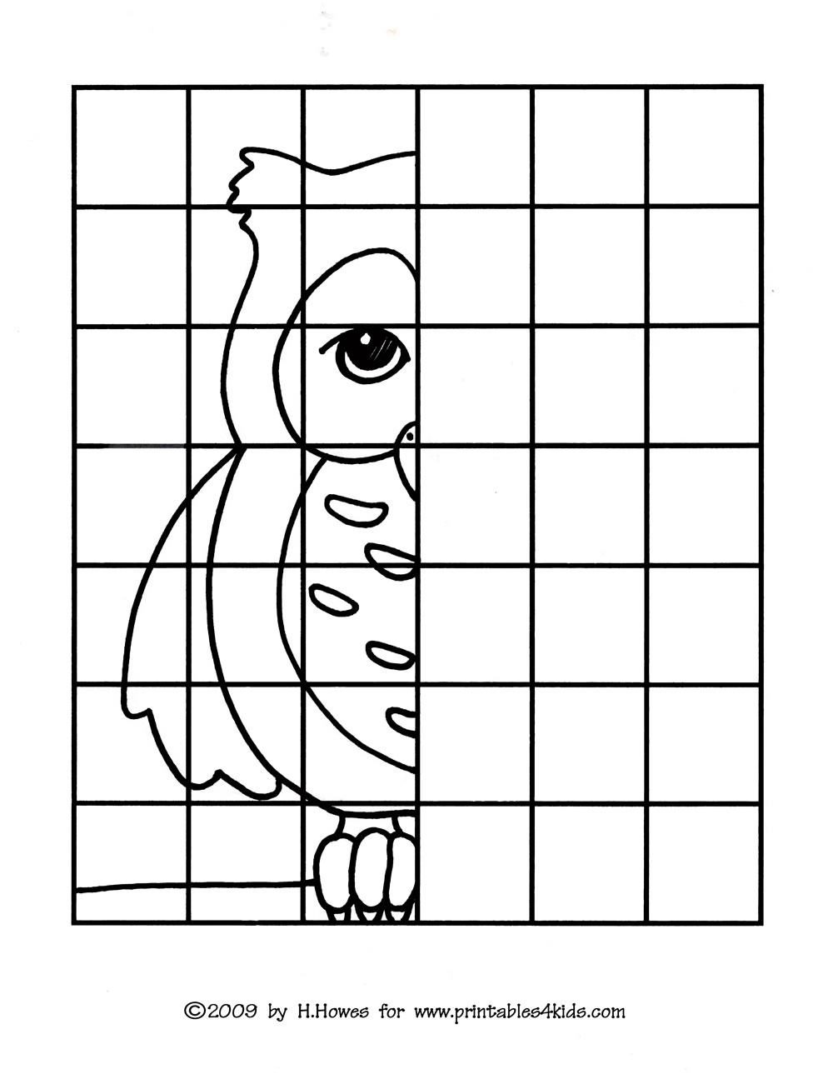

**Q: 3 Help mother hen to find the way and colour the path? 10**

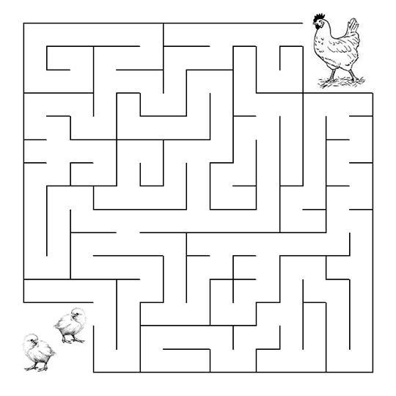

**Q4.Make a pinwheel with the help of color paper? 10**

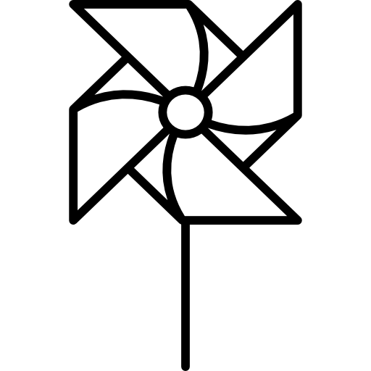

Q5. Copy marks . 10

 **The Knowledge City School**

**Mid-Term Examination 2019 – 20**

|  |  |
| --- | --- |
| Name: | Total Marks: 50 |
| Class: v | Marks obtain: |
| Date: | Time: 2 hrs |

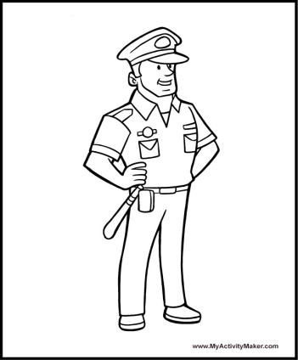 **Q:1 Help policeman to find the path and colour it. 10/**

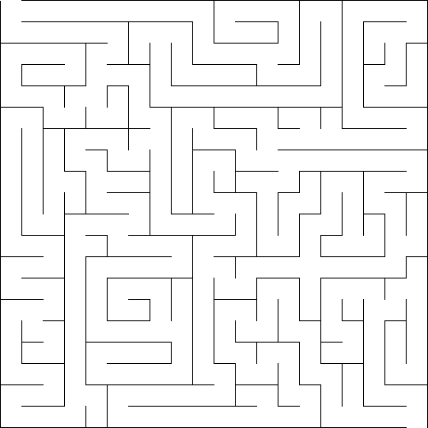

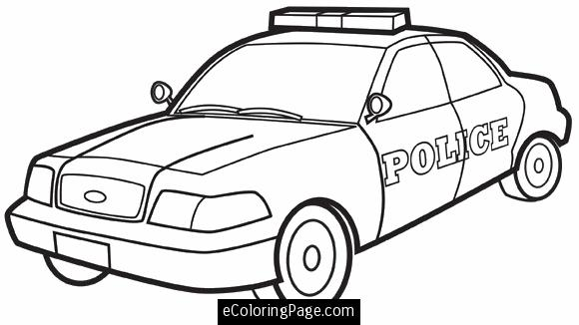

**Q:2 Try to find all of the hidden words in the word search puzzle below. 10/  
 (Words can be spelled forwards, backwards, diagonally, up, or down.)**

|  |  |  |  |  |  |  |  |  |  |
| --- | --- | --- | --- | --- | --- | --- | --- | --- | --- |
| D | P | M | W | F | B | O | Z | I | Q |
| G | M | F | L | Z | N | S | E | K | U |
| V | I | X | O | S | T | K | G | R | E |
| R | P | N | H | R | A | A | G | N | R |
| A | F | E | O | N | T | R | C | I | E |
| B | O | A | S | G | A | U | I | G | P |
| B | O | O | H | O | A | O | N | F | O |
| I | D | B | B | Q | N | R | P | E | I |
| T | X | J | E | G | H | W | D | Z | N |
| N | E | D | N | O | O | M | U | E | R |

**Word List**

|  |  |
| --- | --- |
| **BOAR** | **MOON** |
| **DRAGON** |  |
| **FOOD** | **RABBIT** |
| **FORTUNE** | **SNAKE** |

**Q:2 Complete the picture. 10**

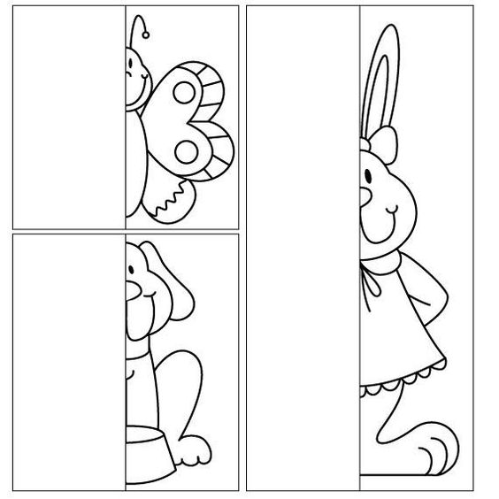

**Q:4 Color the given picture by using one type of stroke. 10**

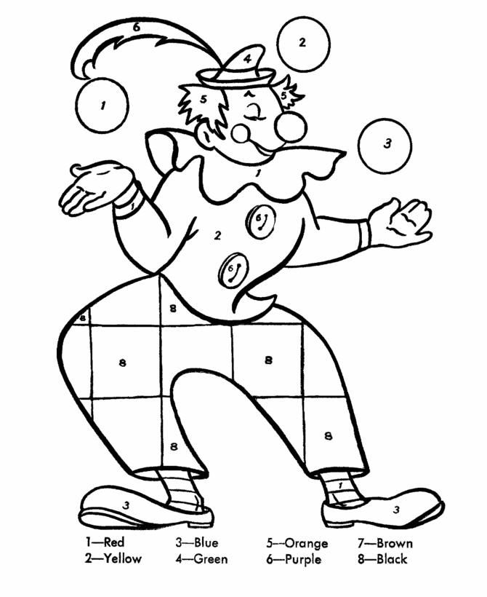

**Q5. Copy marks 10**

**The Knowledge City School**

**Mid-Term Examination 2019 – 20**

|  |  |
| --- | --- |
| Name: | Total Marks: 50 |
| Class: VI | Marks obtain: |
| Date: | Time: 2 hrs |

**Q 1: Color the picture and make shadows. 10**

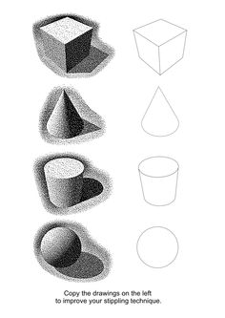

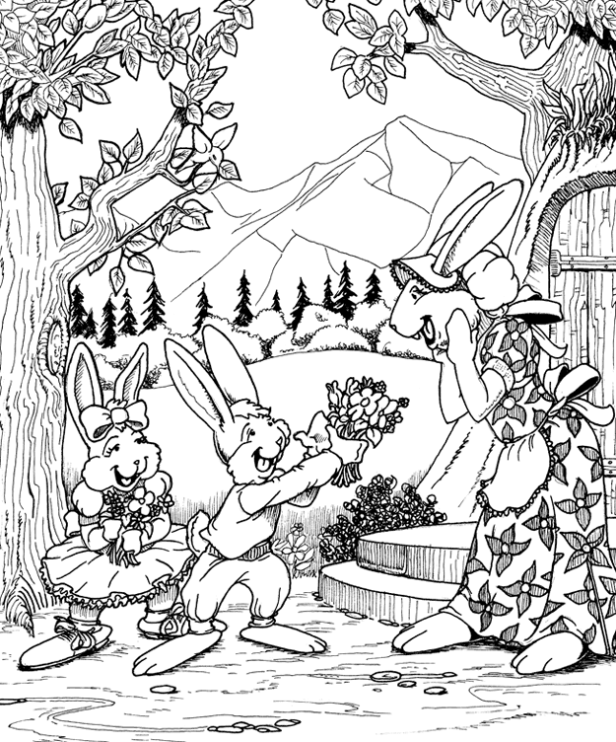 **Q2: Colour the given picture by using one type of strokes. 10**

**Q 3: Find the way. 10**

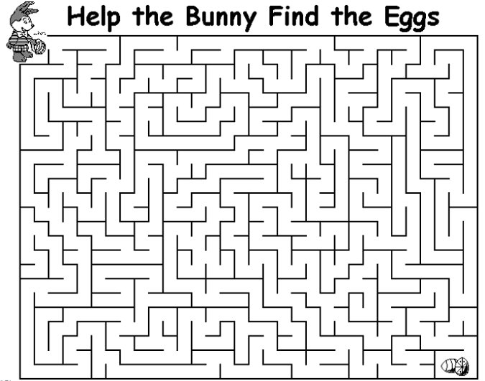

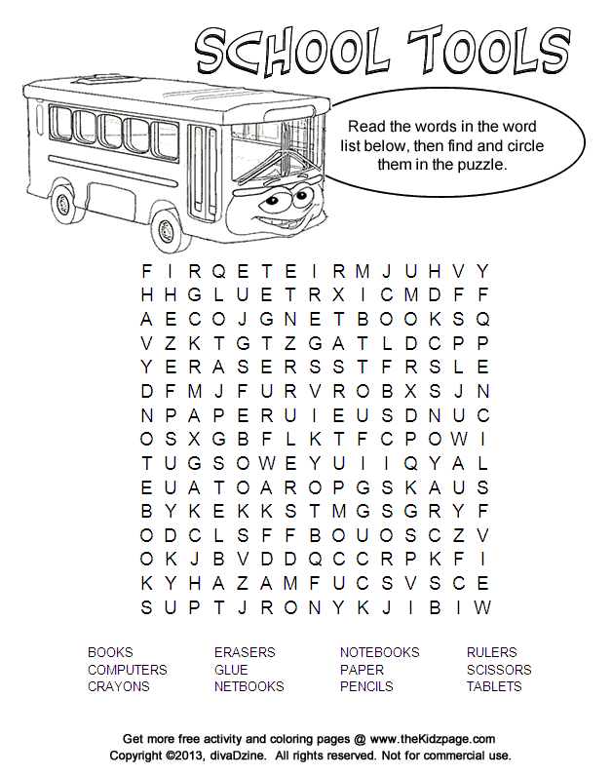 **Q 4: Find and circle the given words . 10**

**Q5:Copy marks 10**